Project 5: Windows Firewall Lab
Tools
- Windows Defender Firewall
Tasks
Create outbound rules.
Block ICMP traffic.
Test with:
ping google.com
Remove rule.
Test again.
Questions To Answer

Windows Firewall
- Create test firewall rules
- Test connectivity

My Findings:
Ok, so I opened Windows Defender Firewall with Advanced Security. This comes pre-installed on my PC with a windows 11 OS. I have a few questions that I want to answer:
- What is the difference between inbound and outbound rules?
- What information does a firewall rule contain?
- How do I disable or remove a rule?
- What happened when ICMP was blocked?
- How do I create a rule?
- How can I verify a rule worked?
First thing I see when opening up the dashboard is inbound/outbound rules, an overview of my settings and a handy “Getting Started” section in case someone wasn’t sure what to do. I know that inbound are rules that affect anything trying to connect to me, and outbound rules are me connecting to anything else, so let’s take a look at them.
I went into inbound traffic first and determined that I play way too many games. I was curious why there are some games on here that I don’t have installed anymore and whether having them still on this list would contribute to any slowdown for my PC.
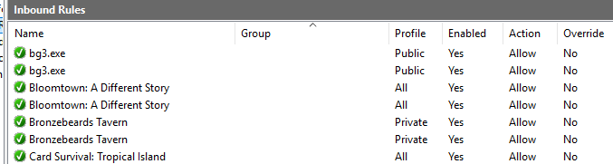
It appears that uninstalling the game doesn’t necessarily always uninstall all the rules for it. Also, while it won’t cause significant slowdown, it does pose a minor security risk for there to be unused/needed rules, so let’s see if we can clean them up. Deleting them was a simple right click and delete, but you can also disable them this way.
I am wondering why there are four rules visible for Teams, so I clicked into the properties to get more info. Here it tells me that it is using UDP, can use any port, and where I can find the program file. checked the other three as well to see what was different. I saw that two used UDP and two used TCP but couldn’t find any other differences. Since they seem identical, it’s likely this was caused by an installation or update.
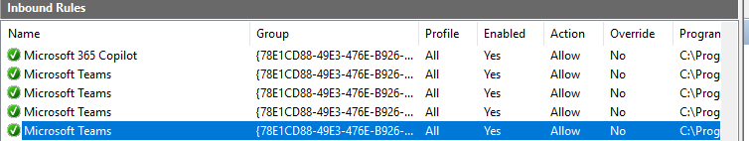
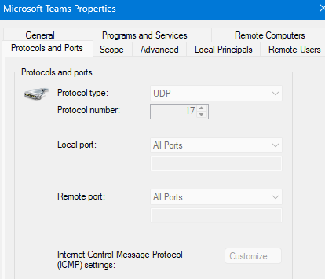
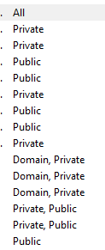
Some rules have different profiles like Public, Private, All, Domain, or even a combination.
Public- This is the most restrictive profile type as it is applied on untrusted networks like hotels or airports. It blocks almost all incoming traffic and prevents the device from being discoverable.
Private- This is for trusted networks like your home or office. This allows you to connect to things like printers and share files on the network.
Domain- This is used when a device connects to an Active Directory.
All- This is used when a rule applies to all of the above profiles.

Next, I want to try and make my own rule. I went into Outbound rules and selected the New Rule action on the right. This gave me a few different choices concerning the type of rule I wished to create. I am going to choose Custom so that I can see all the options available to me.
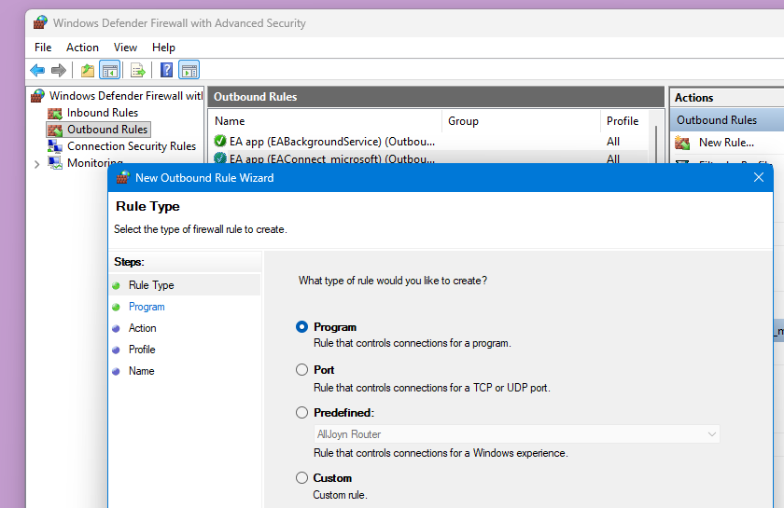

From here I was asked to decide what programs, protocols, and ports this rule would apply to. I chose notepad for the program I was going to test.
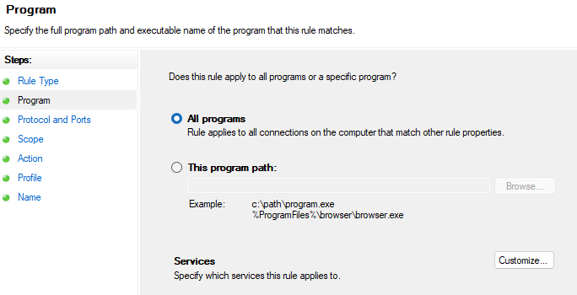
Just to see what options I had and dig around a little I looked at the services option. Selected apply to all and when it got to Protocols, I selected ICMPv4.
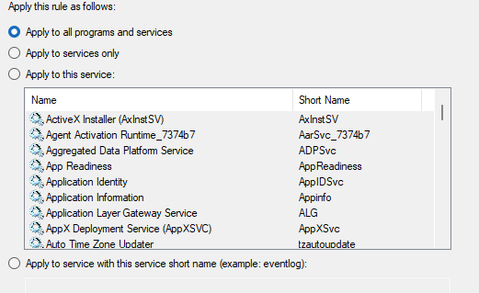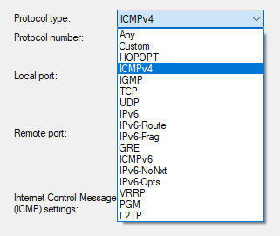
I left scope alone, blocked the connection when prompted to choose an action, set to private profile, and named this rule “Test ICMPv4”. To see if this worked, I opened up CMD and tried to ping Google.com.
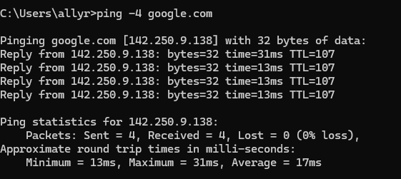
Weird, that shouldn’t have worked..
After troubleshooting, I discovered it only applied to the Private profile while my network was using the Public profile. Once I enabled the Public profile for the rule, ping -4 google.com was successfully blocked.
